Creating IAM Users, User Group & Policies

1. Created users

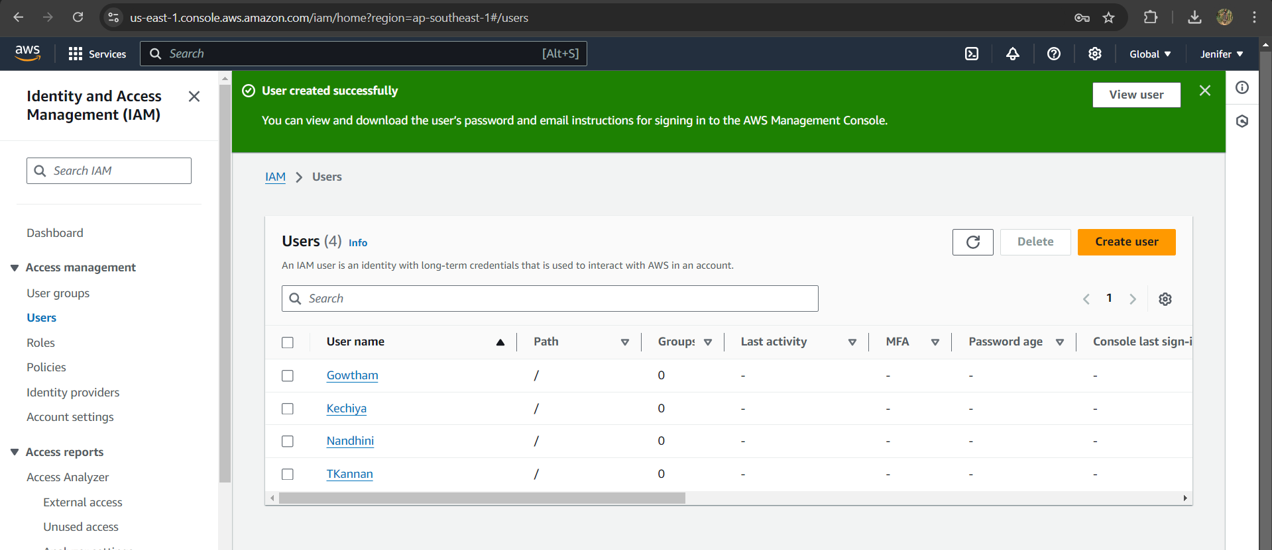

1. Created user group

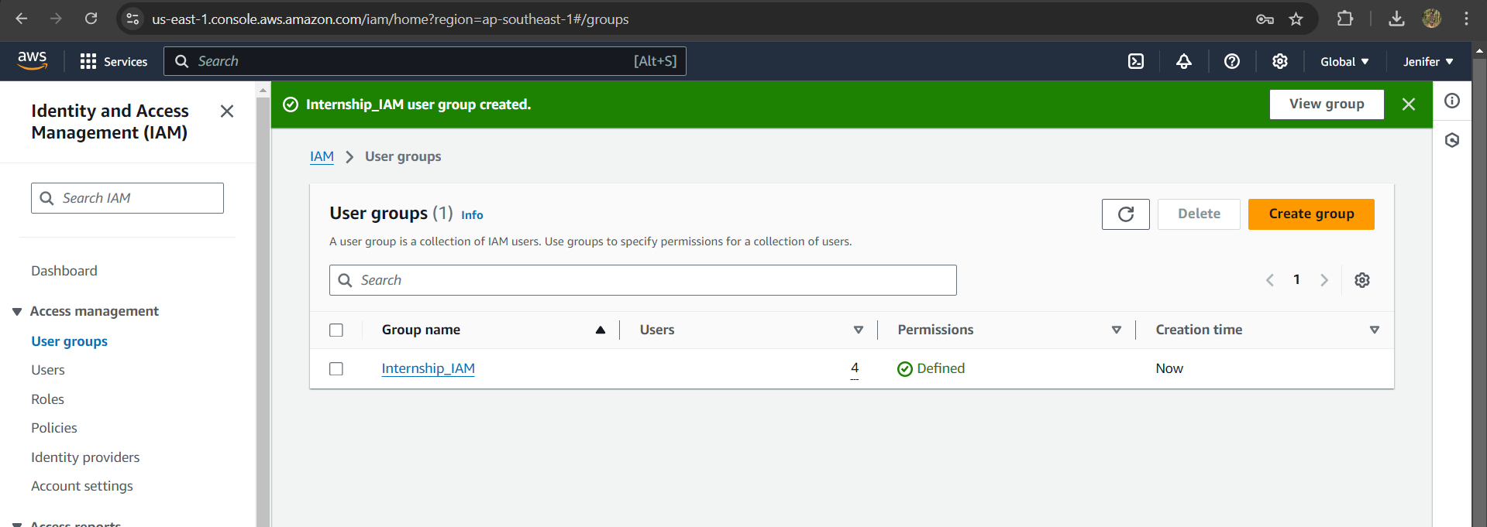

1. EC2 full access & S3 full access given to one of the user

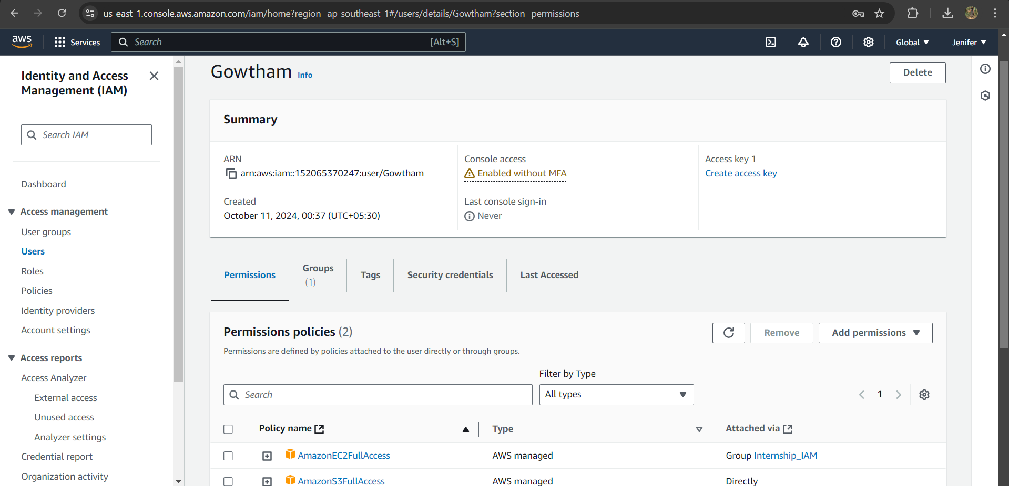

1. EC2 full access given to user groups

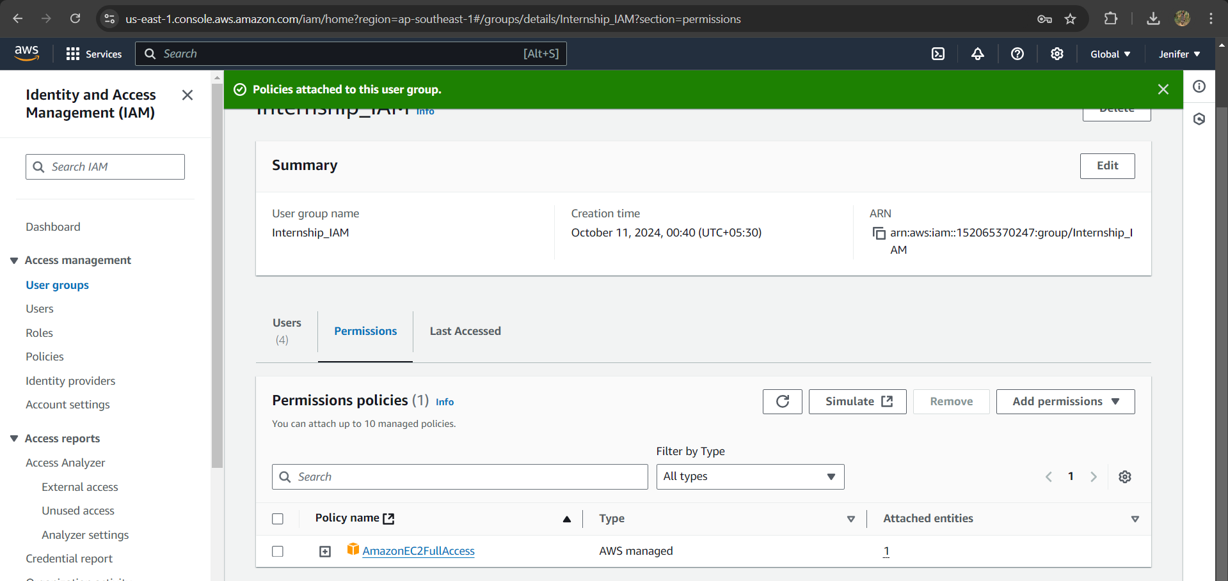

1. IAM user login done by Mr.Gowtham

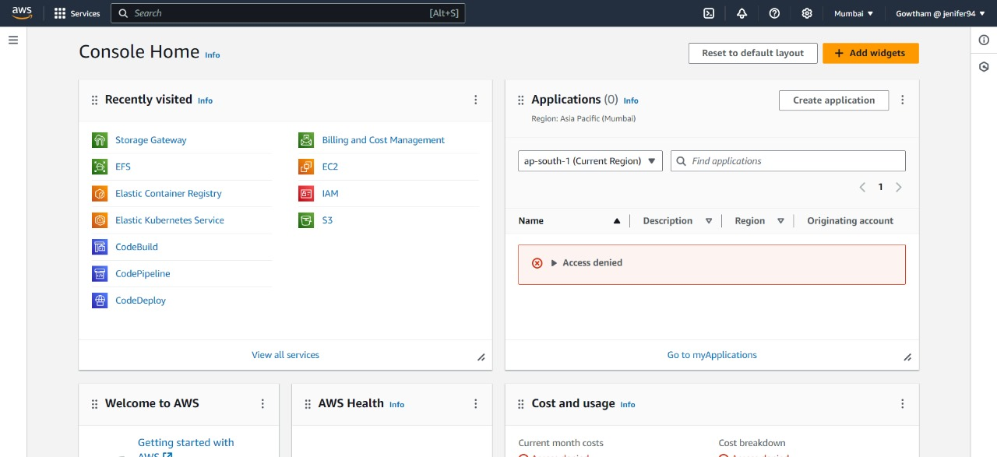

1. S3 Authorization

